Block Diagram (tentative):

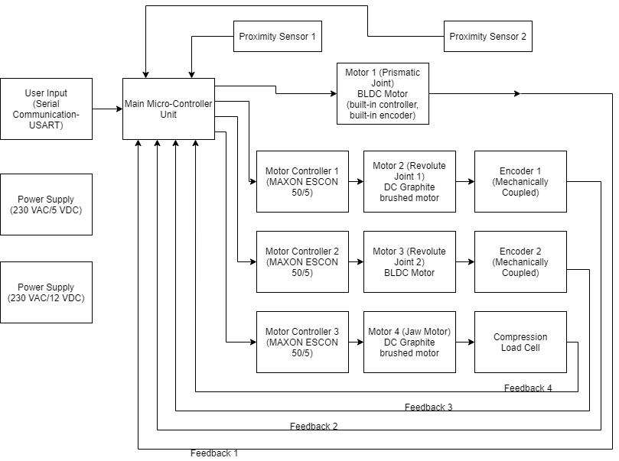

Rough Sketch:

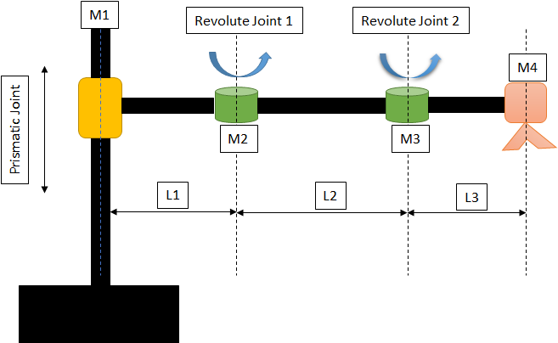

Micro-Controller Comparison:

* + Microchip:
* PIC32MK0512MCF064 – 32-bit architecture (for motor driving)
  + Renesas Electronics:
* R5F513T5AGFL – 32-bit architecture (for motor driving)
* R7FA6M3AF3CFP – 32-bit architecture (for motor driving)
  + STMicroelectronics:
* STM8s – 8-bit architecture (for Motor Driving)
* STM32G0 – 32-bit architecture (for Motor Driving)
  + Texas Instruments:
* TMS320F28379D – C2000 real-time control MCUs (for Motor Driving)
* RM46L450 – Hercules MCUs (for Automation & Control applications)

|  |  |  |  |  |  |  |  |
| --- | --- | --- | --- | --- | --- | --- | --- |
| **Manufacturer** | **STM** | **STM** | **Renesas** | **Renesas** | **TI** | **TI** | **Microchip** |
| **Part Number** | STM8S903K3 | STM32G031x4(_C4) | R5F513T5AGFL | R7FA6M3AF3CFP | TMS320F28379D | RM46L450ZWT | PIC32MK0512MCF064 |
| **Architecture** | 8-bit | 32-bit | 32-bit | 32-bit | 16/32-bit | 16/32-bit | 32-bit |
| **Pins Count** | 32 | 48 | 48 | 100 | 176 | 144 | 64 |
| **Max. GPIO** | 28 | 44 | 38 | 76 | 169 | 101 | 49 |
| **External Interrupts** | 28 | 44 | 6 +1 Non-Maskable Interrupt | 16 +1 Non-Maskable Interrupt | 5 | 10 | 49 (5 programmable) |
| **Timers** | 3 (2 16-bit,  1 8-bit) | 6 | 6 | 13 | 6 | 44 | 9 |
| **A/D Channel** | 1 (7 channels) | 1 (12 channels) | 1 (8 channels) | 1 (19 channels) | 2 (12 channels) + 2 (24 channels) | 1 (24 channels) + 1 (12 channels shared with ADC1) | 7 (26 channels) |
| **RAM** | 1 kB | 8 kB | 12 kB | 64 kB | 128 kB | 128 kB | 128 kB |
| **ROM** | 8 kB | 16 kB | 128 kB | 1 MB | 1 MB | 1 MB | 512 kB |
| **UART Pins** | 1 Set | 2 Sets (USART) +  1 Set (Low_PowerUART) | 3 Sets | 10 Sets | 4 Sets | 2 Sets | 6 Sets |
| **SPI Pins** | 1 Set | 2 Sets | 3 Sets | 2 Sets | 3 Sets | 2 Sets | 6 Sets |
| **I2C Pins** | 1 Set | 2 Sets | 1 Set | 2 Set | 2 Sets | 1 Set | N/A |
| **PWM Pins** | N/A (achieved through Timer) | N/A (achieved through Timer) | 5 Pins | 28 Pins | 24 Pins | 14 PIns | 16 Pins |
| **Operating Frequency** | Upto 12MHz | Upto 64MHz | Upto 32MHz | Upto 120MHz | Upto 200MHz | Upto 200MHz | Upto 120Mhz |
| **Operating Voltage** | 2.95 – 5.5V | 1.7 - 3.6V | 2.7 – 5.5V | 2.7 – 3.6V | 3.3V | 3 – 3.6V | 2.2 – 3.6V  I/O Pins (upto 5V) |
| **Link** |  |  |  | https://www.renesas.com/us/en/document/dst/renesas-ra6m3-group-datasheet?language=en |  |  |  |

Motor Selection:

|  |  |
| --- | --- |
| **Motor Requirements** | |
| Motor Type | Motor 1, Motor 2, Motor 3: Servo Mechanism  DC (Brushless) – BLDC (for less maintenance, repeatability) |
| Operating Voltage | Motor 1, Motor 2, Motor 3: 12 V DC |
| Operating Torque (critical factor)  Safety Factor already considered (value=3) | Motor 1: 0.6 N-m  Motor 2: 22 N-m  Motor 3: 7 N-m |
| Motor Driver | Motor 1, Motor 2, Motor 3: Built-in or additional circuitry |
| Encoder coupling/type | Motor 1, Motor 2, Motor 3: Built-in or mechanically coupled/incremental |
| Mechanical Dimensions/Weight | As compact and lower weight as possible |

* **Motor 1: Torque required 0.6 N-m**

**Option1: Datasheet link:** [**http://cdn.crouzet-motors.com.s3.amazonaws.com/assets/library/Datasheets-and-3D/EN_SMI21_80280001.pdf**](http://cdn.crouzet-motors.com.s3.amazonaws.com/assets/library/Datasheets-and-3D/EN_SMI21_80280001.pdf)

Motor Specs

|  |  |
| --- | --- |
| BLDC Model | Crouzet SQ57 |
| **Part Number** | **80280001** |
| Operating Voltage | 12 – 36 VDC |
| Output Power | 82 W |
| Base Speed | 1100 rpm (at 12 VDC) |
| Driver necessary | No |
| Encoder | Built-in (4096 resolution) |
| Weight | 1.62 kg |

Output Power = (2*pi*speed*torque)/(60)

With speed=1100 rpm, output power=82 W (at 12 V DC)

**Torque=0.71 N-m (satisfied).**

* **Motor 2: Torque required 22 N-m**

**Option 1: (Motor + gearbox + controller + external encoder) system**

**Motor:** <https://www.maxongroup.com/medias/sys_master/root/8841087320094/EN-96.pdf>

**Gearbox:** <https://www.maxongroup.com/medias/sys_master/root/8841188868126/EN-353.pdf>

**Controller:** <https://www.maxongroup.com/medias/sys_master/root/8831198887966/2018EN-442-443-445.pdf>

**External Encoder:** <https://www.cuidevices.com/product/resource/amt11.pdf>

Motor Specs

|  |  |
| --- | --- |
| DC Model | Maxon DCX 35 L, DC Graphite brushed |
| **DC Part Number** | **DCX35L01GBKL434** |
| Operating Voltage | 12 VDC |
| Output Power | 80 W |
| Base Speed | 7610 rpm (at 12 VDC) |
| Weight | 380 g |
| Speed Constant | 699 rpm/V |
| Thermal Time Constant Winding | 44.3 s |

Gearbox Specs

|  |  |
| --- | --- |
| Gearbox Model | Planetary Gearhead GPX 42 UP, 4 stage |
| **Part Number** | **GPX42UPKLSL0243CPLW** |
| Gear Ratio | 243:1 |
| Maximum Torque | 35 N-m |
| Weight | 790 g |

Controller Specs:

|  |  |
| --- | --- |
| Controller Model | Maxon, ESCON Module 50/5 |
| **Part Number** | **438725** |
| Maximum Current | 15A |
| Operating Voltage | 10 – 50 VDC |

Encoder Specifications:

|  |  |
| --- | --- |
| Encoder Model | CUI Devices |
| **Part Number** | **AMT112Q-V-4096** |
| Resolution | 4096 |
| Operating Voltage | 5 VDC |

Speed after gearbox = 7610/243 = **31 rpm**

Output Power = (2*pi*speed*torque)/(60)

With speed=31 rpm, output power=80 W (at 12 V DC)

**Torque=24.4 N-m (satisfied).**

* **Motor 3: Torque required 7 N-m**

**Option 1: (Motor + gearbox + controller + external encoder) system**

**Motor link:** <https://www.maxongroup.com/medias/sys_master/root/8841182969886/EN-241.pdf>

**Gearbox link:** <https://www.maxongroup.com/medias/sys_master/root/8846280032286/20-EN-V2-387-388-389.pdf>

**Controller:** <https://www.maxongroup.com/medias/sys_master/root/8831198887966/2018EN-442-443-445.pdf>

**External Encoder:** <https://www.cuidevices.com/product/resource/amt11.pdf>

Motor Specs

|  |  |
| --- | --- |
| BLDC Model | Maxon EC-max 30 |
| **BLDC Part Number** | **272762** |
| Operating Voltage | 12 VDC |
| Output Power | 60 W |
| Base Speed | 6590 rpm (at 12 VDC) |
| Weight | 300 g |

Gearbox Specs

|  |  |
| --- | --- |
| Gearbox Model | Planetary Gearhead GP 32 C, Ceramic version |
| **Part Number** | **166942** |
| Gear Ratio | 86:1 |
| Maximum Torque | 6 N-m |
| Weight | 190 g |

Controller Specs:

|  |  |
| --- | --- |
| Controller Model | Maxon, ESCON Module 50/5 |
| **Part Number** | **438725** |
| Maximum Current | 15A |
| Operating Voltage | 10 – 50 VDC |

Encoder Specifications:

|  |  |
| --- | --- |
| Encoder Model | CUI Devices |
| **Part Number** | **AMT112Q-V-4096** |
| Resolution | 4096 |
| Operating Voltage | 5 VDC |

Speed after gearbox = 6590/86 = **77 rpm**

Output Power = (2*pi*speed*torque)/(60)

With speed=77 rpm, output power=60 W (at 12 V DC)

**Torque=7.5 N-m (satisfied).**

**Option 2: (Motor + gearbox + controller + external encoder) system into 1 module: All built in**

**Motor link:** <https://robokits.download/downloads/RMCS220x_DCServo_Driver.pdf>

Motor Specs

|  |  |
| --- | --- |
| DC Model | Nema23 High Torque DC Servo Motor |
| **DC Part Number** | **RMCS-2202** |
| Operating Voltage | 12 VDC |
| Output Power | 76.5 W |
| Base Speed | 18000 rpm (at 12 VDC) |
| Gearbox Ratio | 180:1 |
| Speed at Shaft | 100 rpm |
| Driver necessary | No |
| Encoder | Built-in (1800 resolution) |
| Weight | 180 g |

Speed after gearbox = 18000/180 = **100 rpm**

Output Power = (2*pi*speed*torque)/(60)

With speed=100 rpm, output power=76.5 W (at 12 V DC)

**Torque=7.3 N-m (satisfied).**

* **Motor 4: Torque required 0.6 N-m**

**Option 1: (Motor + gearbox + controller + external encoder) system**

**Motor:** <https://www.maxongroup.com/medias/sys_master/root/8841087254558/EN-95.pdf>

**Gearbox:** <https://www.maxongroup.com/medias/sys_master/root/8841188474910/EN-347.pdf>

**Controller:** <https://www.maxongroup.com/medias/sys_master/root/8831198887966/2018EN-442-443-445.pdf>

**External Encoder:** <https://www.cuidevices.com/product/resource/amt11.pdf>

Motor Specs

|  |  |
| --- | --- |
| DC Model | Maxon DCX 32 L, DC Graphite brushed |
| **DC Part Number** | **DCX32L01GBKL448** |
| Operating Voltage | 12 VDC |
| Output Power | 70 W |
| Base Speed | 6560 rpm (at 12 VDC) |
| Weight | 320 g |

Gearbox Specs

|  |  |
| --- | --- |
| Gearbox Model | Planetary Gearhead GPX 32, 1 stage |
| **Part Number** | **GPX32AAKLSL05D3CPLW** |
| Gear Ratio | 5.3:1 |
| Maximum Torque | 1.25 N-m |
| Weight | 140 g |

Controller Specs:

|  |  |
| --- | --- |
| Controller Model | Maxon, ESCON Module 50/5 |
| **Part Number** | **438725** |
| Maximum Current | 15A |
| Operating Voltage | 10 – 50 VDC |

Encoder Specifications:

|  |  |
| --- | --- |
| Encoder Model | CUI Devices |
| **Part Number** | **AMT112Q-V-4096** |
| Resolution | 4096 |
| Operating Voltage | 5 VDC |

Speed after gearbox = 6560/5.3 = **1234 rpm**

Output Power = (2*pi*speed*torque)/(60)

With speed=1234 rpm, output power=70 W (at 12 V DC)

**Torque=0.54 N-m (satisfied).**